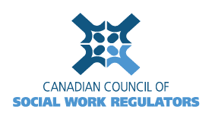 

# CCSWR Strategic Goals 2017-2018 - DRAFT

1. Review and **confirm CCSWR’s purpose, structure and goals**
   * Strategic Plan goals and objectives agreed upon for 2017
   * Terms of Reference drafted and agreed upon
   * Bylaws reviewed and updated
   * Vision reviewed and updated

# Actively support and participate in Intersectoral Committee goals

* + Representatives appointed for committed leadership and representation toward agreed goals of the Committee

# Initiate action to address interjurisdictional practice issues and needs

* + piloted draft memorandum of understanding with identified provinces
  + active sub-committee leads identified; project initiated with plan in place to track and report issues and results

# Explore HRSDC grant opportunities

* + decision made with respect to pursuit of funding
  + Revise goals and work with HRSDC to pursue grant, if applicable